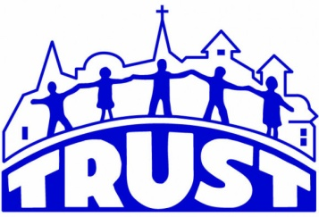
TRUSTworthy News
Toward Renewed Unity and Service Together
TRUST Inc Is Committed to Uniting and Mobilizing Community Partners
To Serve and Empower our Neighbors
9 West Rustic Lodge, Minneapolis, MN 55419
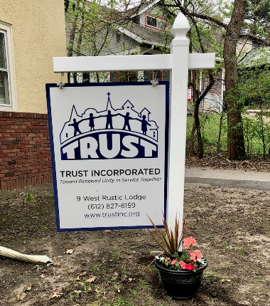
Phone: 612.827.6159 Website: www.trustinc.org

Spring Has Sprung At TRUST Inc
You may know us through Meals on Wheels, Chore Home Services, Grocery/Errand Transportation Services or Trusty Salers Estate Services. Together, we are a 501C3 non-profit agency that partners with communities of faith and communities of neighbors to help seniors 55+ and those with disabilities remain safely in their homes. We are located at 9 West Rustic Lodge, Minneapolis MN 55419. You may ask, “Where’s that?” The easiest answer is we are two story white duplex just west of Nicollet Avenue at about 48th and ½ street (aka Rustic Lodge). This summer we are planning to put in an accessibility ramp to the front door, rain gardens and some window boxes we hope to fill with colorful impatiens! We are open 9:00 a.m. – 2:00 p.m. Monday – Thursday. Stop on by and say hello! We would love to see you!

Community Connections Month-by-Month
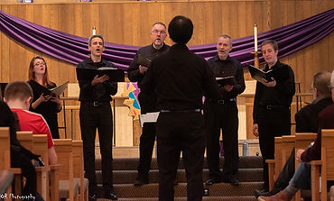
At TRUST Inc as we continue to create community with the community. We dodged the rain (and snow) drops on March 05 for our first annual Spring Market and Craft Fair held at Diamond Lake Lutheran Church. Mark your calendar now for the Fall Market & Craft Fair Oct 22.
We were blessed to have the Caritas “Inspiring Harmony” benefit concert April 10 hosted at Richfield Lutheran Church, raising $1500.
Join us May 22 for Spring into Summer “picnic and music” celebration with games, free meal and community fun at Diamond Lake Lutheran Church. See poster in this newsletter
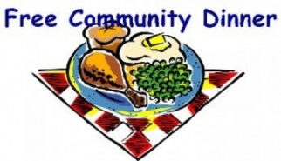
Join us June 26, July 24 & August 28 at 5:00 p.m. for Sunday Suppers – a Sunday Meal option for all ages. The meal is free – but any donation will help support this opportunity to be weekend community together. Located at Diamond Lake Lutheran Church, 5760 Portland Avenue south. Meal and fellowship start at 5:00 p.m. A community partnership with Diamond Lake Lutheran Church. Some transportation available to our neighbors! Call the TRUST Offices for a ride, to volunteer for meal prep, volunteer driving or serving: 612.827.6159

Donations Made Easy With TRUST Inc QR Code
Help us with our “Seed the Need” initiative that allows TRUST to fund community needs through the generosity of people like you! Our new “Sunday Suppers” is one of our first projects as part of our Food Sustainability Hub Initiatives. You can help us ‘seed the need’:scan this QR code or use this link https://givebutter.com/TRUSTinc for your giving. Thank you for your generosity!

PLEASE SHARE THE FOLLOWING WITH YOUR COMMUNITY & FRIENDS!

Spring has Sprung – Let us help you with your Spring Cleaning and Yard Maintenance Needs!
Build Relationships - Thru Us!
At Trust Inc we offer Part-Time Work for people ages 16+ through Adults in our Chore Home Services program. It’s a great way to earn $ on your schedule. Hiring now for Spring and Summer job opportunities! Please share!
"DATE CHANGE"
JOIN US AS WE SPRING INTO SUMMER MAY 22, 2022 Hosted by our partners at Diamond Lake Lutheran Church
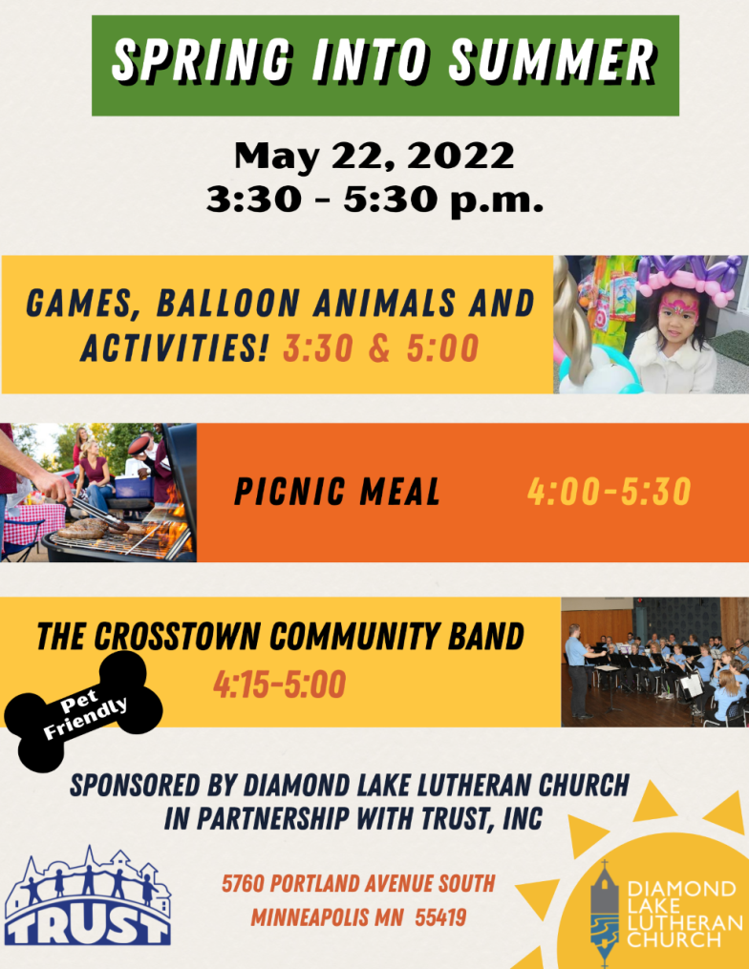

Join us June 14, July 12 & August 09
Join us for monthly summer fun and social hour!
“Yappy Hour 2nd Tuesday Night Trivia”
Starts June 14 – weather permitting!
Hosted on the Trust Inc front lawn.
6:30 – 8:00 p.m. $5/donation per person
Meet & Greet our neighbors, Fun trivia, prizes, snacks, beverages for sale and of course, water bowls and treats for our four-legged canine friends! Leashes required.

