
TRUST-worthy News
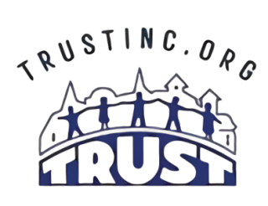
April 2026
Toward Renewed Unity and Service Together
TRUST Inc Is Committed to Uniting and Mobilizing the
Community to Serve and Empower our Neighbors!
9 West Rustic Lodge, Minneapolis, MN 55419
Phone: 612.827.6159 Website: www.trustinc.org

TRUST Inc Welcomes Spring!
At TRUST Inc., we provide a variety of services to support aging adults and individuals with disabilities in South Minneapolis. Our programs are designed to enhance the quality of life by helping individuals maintain their independence while staying connected to their community. If you are in need of transportation, home chore work or meal delivery please reach out to us at 612-827-6159 and let us know how we can help. We also offer monthly opportunities for social engagement and connection with others through our community initiatives. Here’s the short list of upcoming activities (details further in the newsletter)

- April 01 - Chore Home Services starts Spring Yard Clean Up and Lawn Services Sign Up
Schedule by calling 612-827-6159
- April 08 - Conversation Café Volunteers #1 – 1:30 – 3pm Rustic Lodge Office
- April 09 – Cribbage Club 1-3 pm Judson Church
- April 14 – Chair Yoga 3-4pm Diamond Lake Lutheran Church
- April 21 – Journey Café Discussion Group 10am – 11:30am Diamond Lake Lutheran
- April 22 - Conversation Café Volunteers#2 – 1:30 – 3pm Rustic Lodge Office
- April 23 – Fall Prevention Workshop 10 – 11:30 am Diamond Lake Lutheran
- April 26 – Volunteer, Community & Client Appreciation Sunday Supper 4-6pm
featuring music by The TRUST Ramblers Dixieland Band
- May 07 – “Lunch & Learn It” Special May Mini Senior Fair
*Special time* 10:00 a.m. – 2:00 pm – Bethlehem Lutheran Church
- May 17 – Spring Into Summer Sunday Supper 4p – 6p featuring the music of
The Crosstown Community Band

*** Transportation Services Fees & Payments Effective April 01***

Starting April 1, 2026, the price for a round-trip ride will increase from $5 to $7. This adjustment will allow us to continue offering quality rides with our dedicated and conscientious drivers while maintaining our affordable services despite rising expenses. Additionally, we will introduce a monthly invoicing system for rides, eliminating the need for clients and drivers to carry cash. For more information, contact the office at 612-827-6159.
Schedule your spring clean-up and yard maintenance today!

It's time to "Think Spring!" Don’t wait—schedule your spring yard cleanup, window cleaning, storm window screen replacement, and lawn mowing services today through TRUST Inc’s CHORE Home Services program. We would love to get you on the schedule as soon as possible.

In addition to these services, we also offer housekeeping and simple home repairs. Please note that you must call to be added to the 2026 spring cleanup and summer mowing schedule. We need to hear from you!
Call Whitney at 612-827-6159.

News From Health & Wellness – Stress Awareness Month

April is Stress Awareness Month, focusing on the impact of stress on seniors. As individuals age, they often face unique stressors like health issues, financial worries, grief, and social isolation, which can lead to anxiety and depression.

This month encourages open conversations about these challenges and effective coping strategies. Engaging in physical activity, pursuing hobbies, and maintaining social connections can help seniors manage stress and enhance their well-being.

Local communities may offer resources to support seniors, such as workshops and support groups. It's important to promote a healthy lifestyle, foster social connections, and establish routines, including regular exercise, a balanced diet, and relaxation techniques.

Let’s support our senior community by acknowledging their struggles and providing them with the tools to manage stress. For more information, contact Rose Huttner at TRUST Inc. at 612-481-5525.
April 26 – Sunday Supper Celebrates Volunteers, Clients and Community!
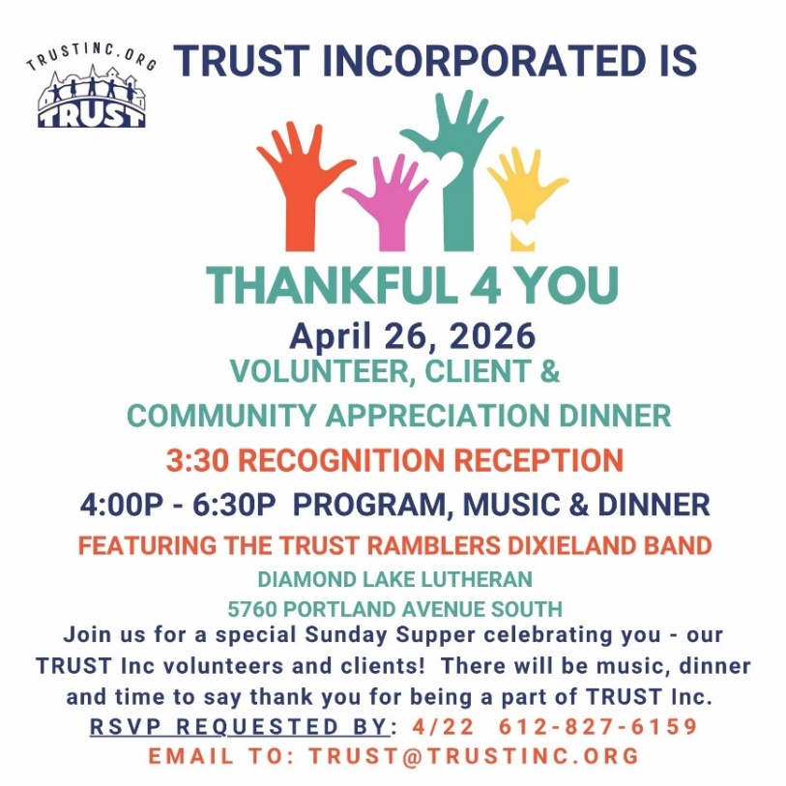
At TRUST Inc., we are grateful for our volunteers, clients, and the community! Each April, we come together to express our thanks with music and a meal at our Sunday Supper.
This year, Sunday Supper on April 26 will be a celebration filled with love and gratitude for the community we support and those who support us.

Join us for an evening of music, dinner, raffles, and the opportunity to say “thank you” as we honor our volunteers, clients, and community.Please let us know if you can attend by RSVPing by April 22, so we can plan for food and seating just for you!
Call 612-827-6159 or email trust@trustinc.org to RSVP your attendance!
May 07 Lunch & Learn Offers May Mini Senior Fair!

May Lunch & Learn It will bring a variety of learning topics in a Mini Senior Fair Setting. The expanded workshop (10 am-2 pm) will provide all the great parts of Lunch & Learn It and some additional mini-session on a variety of topics.

Themes include; Mental Health, Self Care, Yoga/Meditation, Technology Safety, Health & Wellness, Decluttering Tips and more.

Limited Seating – Reserve Your Space TODAY! Call 612-827-6159 or trust@trustinc.org.
Spring Community Initiatives – Join us often and please share!


TEACH AND TRAIN THURSDAY RETURNS
Join us April 23 for a Fall Prevention and Home Safety Workshop sponsored by our partners at START Senior Solutions.

The workshop will include teaching and training techniques, along with hands-on practice in both standing and seated positions, to help you best prevent falls.

This is a very important training workshop for all older adults and we hope you will attend.

The cost is FREE for TRUST Inc clients and there is a $10/person fee for community attendees.

Call today to register at 612-827-6159

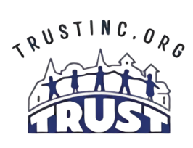
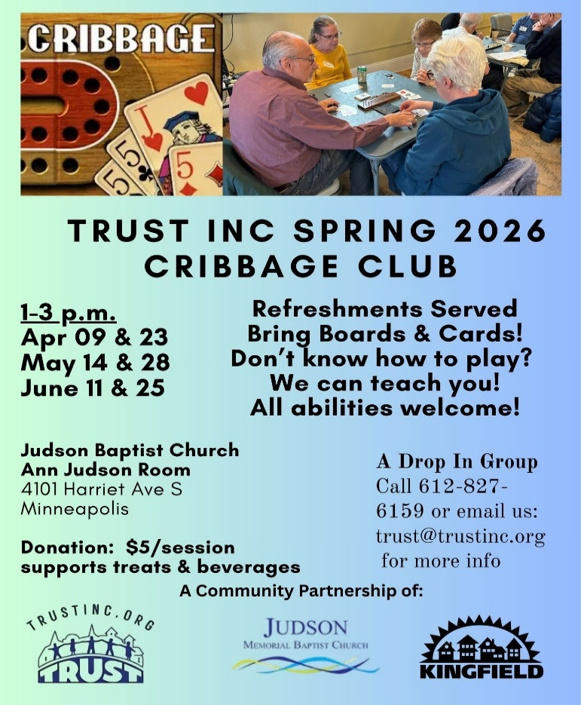
Your Donation Helps TRUST Inc Provide Program Services For All!
At TRUST Inc., we strive to never turn anyone away in our service area due to an inability to pay. Your contributions help us make this possible. Be a living legacy for someone today!
We can gladly accept your donation of any amount as follows:
- by mailed check to:
- 9 West Rustic Lodge Minneapolis MN 55419
via our website links: https://www.paypal.com/paypalme/TRUSTINCMN OR https://www.givemn.org/organization/Trust-Inc

Or thru this secure QR Code




TRUST INC PROGRAM SERVICES – We are here for you!

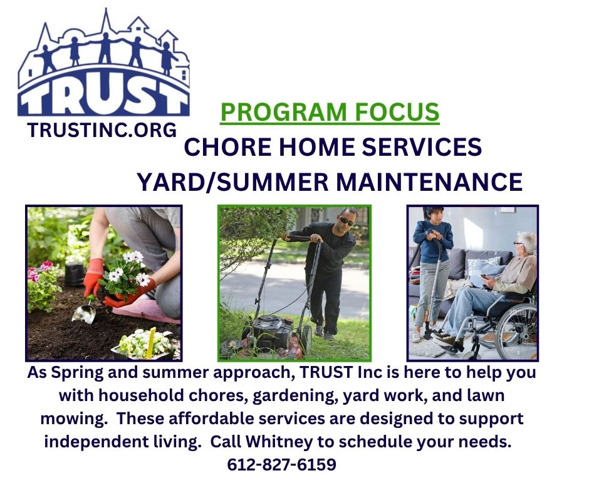
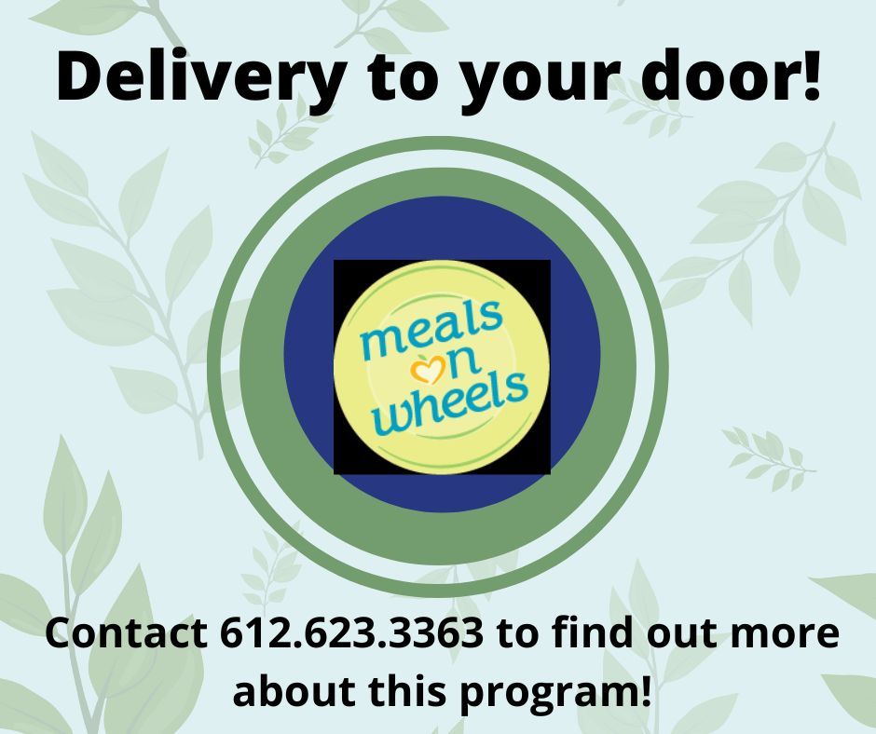

from you TRUST Inc Staff Team!




